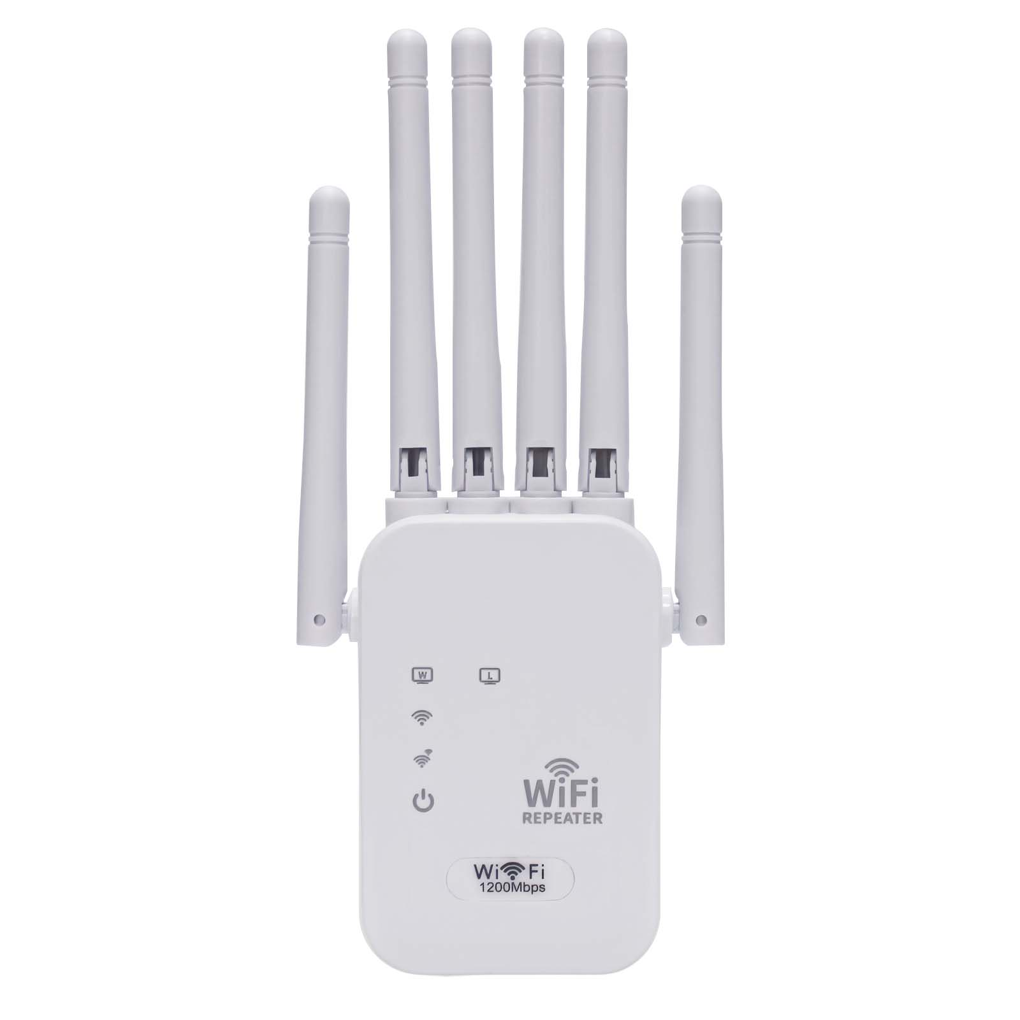
Product Characteristics
- Six external 3DB omnidirectional antennas;
- Support relay mode, AP mode;
- Built-in 100~240V 50/60Hz AC power module, no external power adapter;
- There are multiple specification standard plugs available for selection, supporting the Chinese standard, European standard, American standard, British standard, etc.
- 1200Mbps transmission rate, dual-band, at the same time support 2.4GHz &5.8GHz frequency band, anti-interference ability is stronger, wireless transmission faster and more stable;
- The device is equipped with two 100M RJ45 ports. It supports the conversion from wireless to wired connection and can be connected to desktop computers, laptops, etc. for wired Internet access.
- Professional intelligent WiFi relay, support WiFi hotspot automatic scanning, and WiFi hotspot memory function;
- Support WEB background Chinese-English dual language interface, one-click setting wizard, quick and simple configuration;
- With good compatibility, compatible with all smart phones, tablets, laptops and other WiFi devices.
Product Specifications
Product Name |  | 1200M Dual-band Wireless Repeater
Product Model |  | Z1200C
Hardware Specifications
Hardware System | Main chip |  | MT7620A+MT7612EN
Hardware System | Memory |  | DDR2 64MB
Hardware System | FLASH |  | 8MB
Wireless Parameters | Protocol standards |  | Support IEEE 802.11ac while backward compatible with IEEE 802.11a/b/g/n
Wireless Parameters | Operating frequency band |  | Dual band, support both 2.4GHz and 5.8GHz (11AC)
Wireless Parameters | Wireless rate |  | 1200Mbps(2.4 GHz：300 Mbps + 5.8 GHz：867 Mbps)
Wireless Parameters | Transmit power |  | 2.4 GHz：18dBm ± 1 dBm  5.8 GHz：18dBm ± 1 dBm
Wireless Parameters | Antenna gain |  | 3dBi omnidirectional antenna *6
Wireless Parameters | Reception sensitivity |  | -90dBm ± 2dBm
Physical Interface | Network interface |  | 10/100Mbps LAN port *2
Physical Interface | Button |  | 1 reset key /WPS key
Indicator Light | LED indicator |  | PWR/WIFI/Repeater/LAN/LAN in that order
Power Supply/  Power Consumption | Mode of power supply |  | AC 100~240V 50/60Hz
Power Supply/  Power Consumption | Plug-type |  | Optional, support China, European, British, US and other specifications,etc
Power Supply/  Power Consumption | Power of the machine |  | < 5 w
Product Accessories | Device host |  | 1200M dual band repeater host *1
Product Accessories | Other |  | User Manual *1, Certificate *1
Appearance/Packaging | Product dimensions |  | 180mm*84mm*34mm (L*W*H, does not include plug size)
Appearance/Packaging | Appearance color |  | White
Appearance/Packaging | Weight |  | 100g
Appearance/Packaging | Package size |  | 195*90*70mm（L*W*H）
Other | Covered area |  | 0 - 80㎡
Other | Use environment |  | Working temperature: -10℃ ~ 55℃  Storage temperature: -40℃ ~ 70℃  Working humidity: 10% ~ 90%RH non-condensing  Storage humidity: 5%-95%RH Non-condensing
Software Specifications
Network | Work mode |  | Relay mode, AP mode
Wireless Security | Wireless security |  | Supports WPA2, WPA, WPA2-PSK AES, WEP encryption
Other | Product features |  | Professional intelligent WIFI repeater, support hotspot automatic scanning, support WIFI hotspot memory function
Other |  |  | At the same time support 2.4GHz and 5.8GHz two bands of the network, the signal coverage is wider, the transmission rate is faster and more stable, and the anti-interference ability is stronger
Other | Number of user connections |  | Maximum number of user connections is 35
Other | System language |  | Chinese-english dual language adaptive
Other | Management mode |  | Web Configuration Management
Other | Applicable scenarios |  | Multi-home, duplex, cross-floor, rental house, apartment, villa, etc

Product size:
